An independent pharmacy made this happen. Not a chain. Not mail order.

Support and strengthen our family owned pharmacy.

Just think about what we could do next…

Visit Neal’s blog: drnealsmoller.com/learn

 | Dr. Neal Holistic Pharmacist
 | facebook.com/DrNealSmoller
 | instagram.com/DrNealSmoller
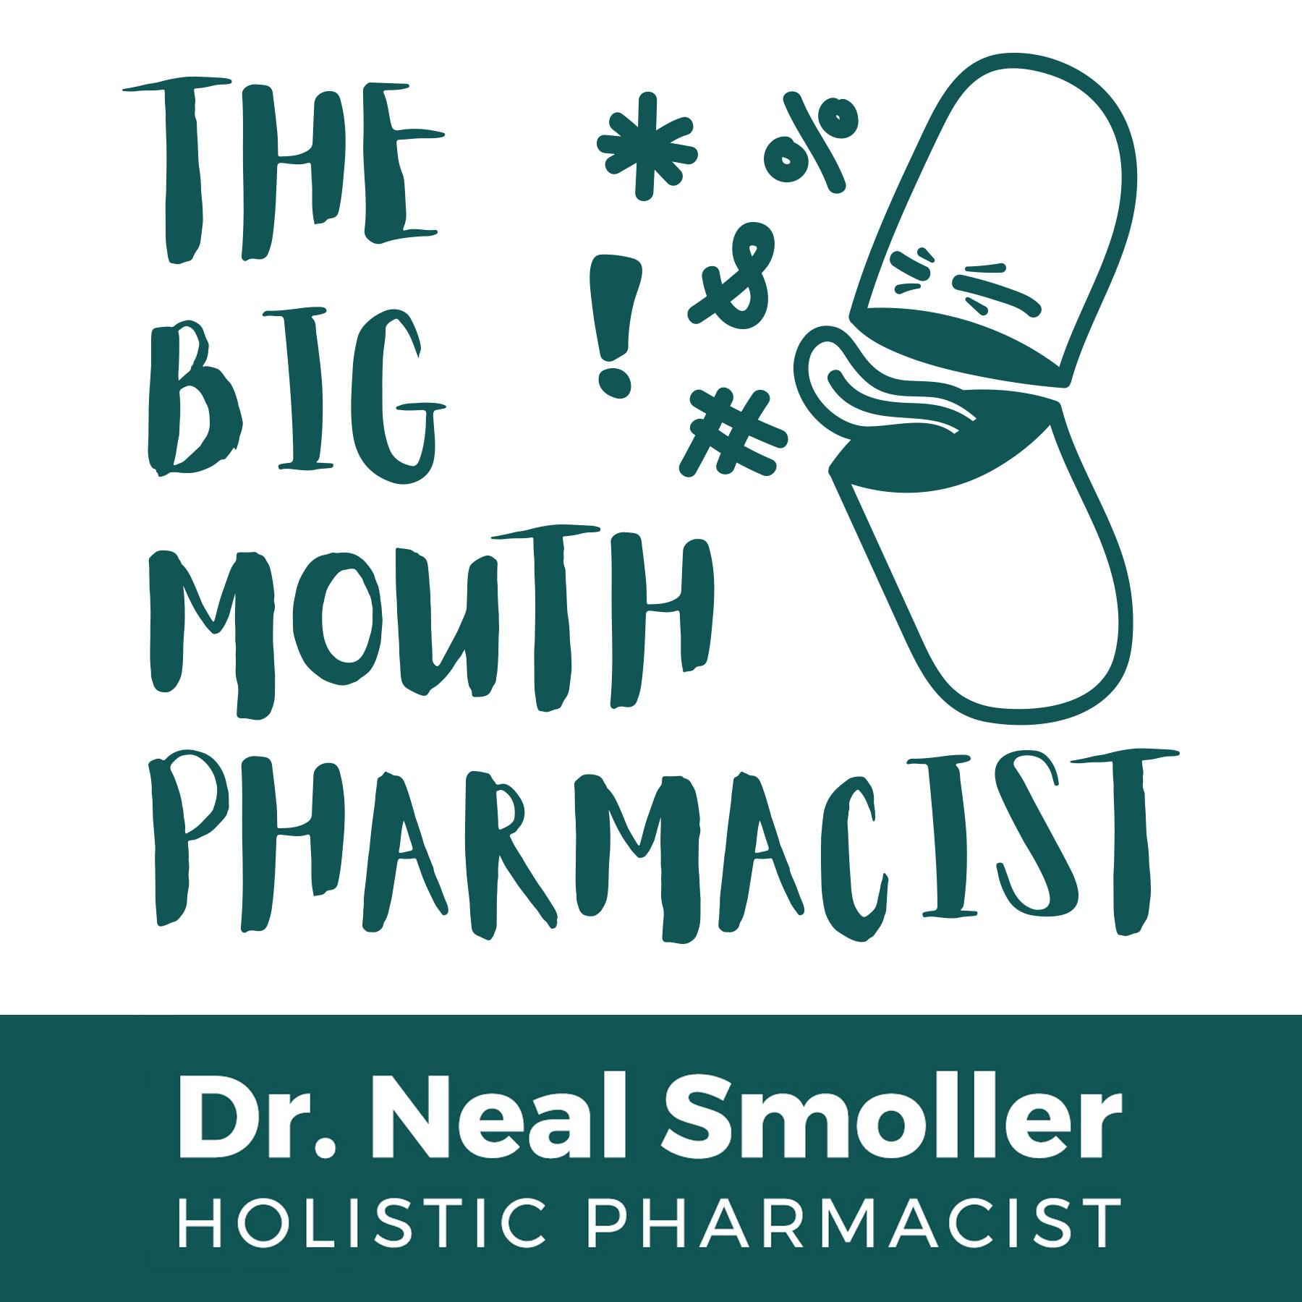 | The Big Mouth Pharmacist Podcast

